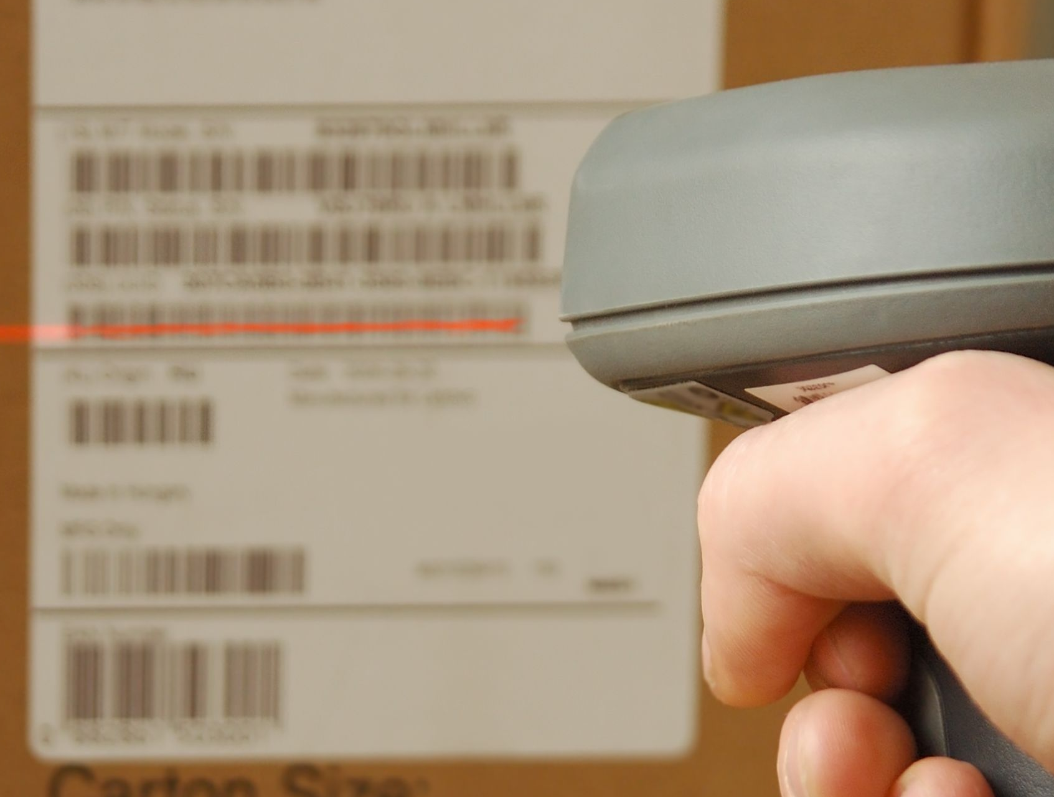





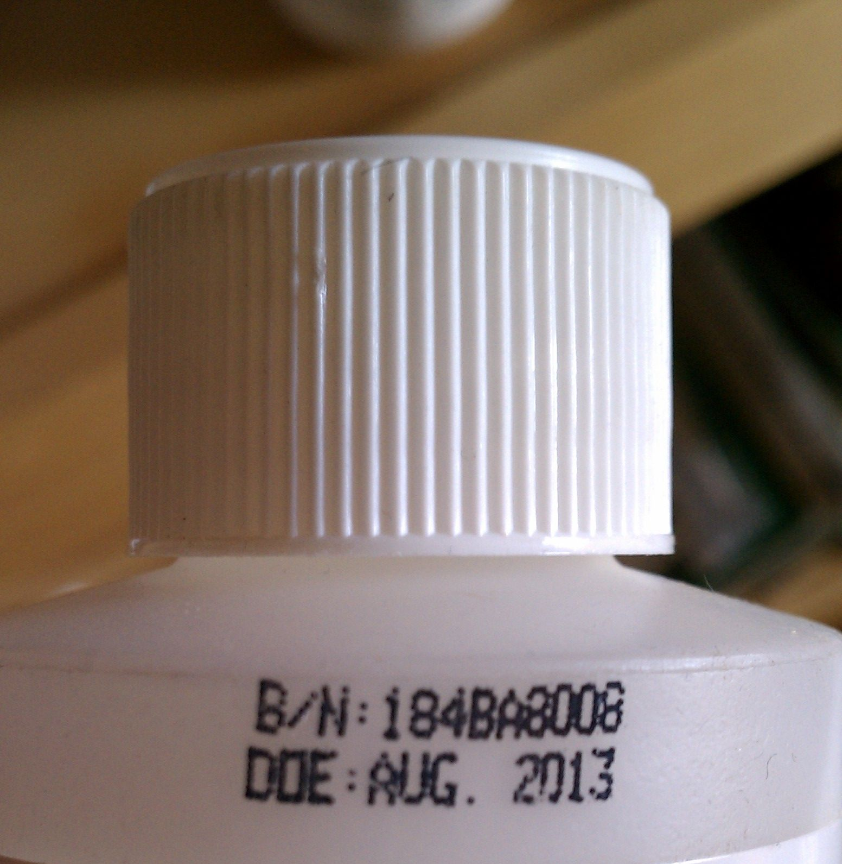


Finale Inventory’s cloud-based architecture allows companies to track inventory operations. From inventory control, shipping and receiving to order fulfillment, Finale helps businesses simplify warehouse operations, saving money and time with improved efficiency, accuracy and reporting.

Regardless whether you have one location or many locations, Finale Inventory gives all departments a consistent, real-time view of inventory stock levels. Follow-up phone calls to the warehouse team to confirm stock levels will become nonexistent. With tracking by sublocation and bin location, warehouse team members know exactly where to locate the stock.

In addition to the powerful inventory management capabilities, Finale also comes with integrated purchasing, order management, and return modules to simplify the daily operation of your business.
Finale allows teams to avoid wasting energy inputting repetitive data in different software, but rather spend time on more important business tasks.

The heart of the software is an intuitive, yet powerful inventory management solution. Finale removes the complexity of inventory management and easily handles all your stock movements from purchasing to shipping orders, allowing you to focus on other parts of the business.

Finale additionally offers an integrated barcode scanner solution designed to improve the warehouse efficiency and eliminate human errors. The turnkey barcode solution is designed to be a comprehensive barcode solution that will work right out-of-the-box.

The inventory management complexity compounds when you need to keep tracks of batch codes, lots, or serial numbers. Finale makes it easy to keep track per-stock-unit information from the start (receiving or manufacturing) to finish (shipping the products).

Our objective is to enable companies to increase efficiency and grow their business by offering a powerful inventory management solution with unsurpassed customer service at an affordable monthly price. Contact us today and learn how Finale can help take your business to the next level.

Finale Inventory for
Warehouse Management, Wholesalers, and Distributers

Lot and Serial Number Tracking. Finale Inventory allows you to create and track your products via batches, lots, or serial number. Finale ensures clear traceability of your products and makes it easy to track per-product information from receiving to shipping. If your industry mandates that you maintain accurate records by lot for purchase and sale (e.g. medical supplies, fireworks, health foods, etc.), then Finale Inventory is all you need for regulatory compliance documentation with comprehensive audit trail of stock changes. Finale has been approved by the ATF (Bureau of Alcohol, Tobacco, Firearms and Explosives) for record keeping compliance in some industries.
Multi-Location Support. As companies grow, businesses typically will add new locations to support their operations. But keeping track of inventory among multiple warehouses is more challenging and more complex. Finale Inventory solves this problem with inventory tracking tools that allow you to monitor stock levels by each sublocation or bin location, receive and pick products by each location, and transfer stock between locations.

Monitor inventory levels by location
Receive or pick inventory at each location
Quickly transfer products from one location to another
Report and Documentation Customization. Create your own custom layouts if you require customized documents to send out. Whether it’s purchases orders, invoices, packing slips or bills of lading, Finale Inventory lets you customize them exactly how you want them. Have unique barcode labels requirements? No problem. Finale can generate custom barcodes and custom label formats.
Turnkey Mobile Barcode Solution. Finale’s custom scanner software works with any Windows mobile barcode scanner to allow warehouse workers to perform warehouse operations quickly with fewer errors. Functions such as receiving, picking, conducting stock takes and stock transfers are quick and easy. After they’re finished, simply sync from the scanner to Finale making the changes available to everyone.
Leverage existing UPC codes to simplify the set-up. If the products do not have barcodes, Finale can generate custom barcodes that meets your needs.

Finale Capabilities
"I used to do stock takes with pen and paper. Using Finale and a mobile barcode scanner I get it done in half the time. Last Saturday I never would have finished doing stock takes for my 60 sublocations without the scanner and Finale. Finale has streamlined our backend operations saving us both time and money!”
Robert Felton, Operations Manager, Miami Restaurant Supplies

QuickBooks integration. Finale directly integrates with both QB Desktop and QB Online to ensure all information between the two systems remains consistent. Finale syncs down information such as purchase orders, sales invoices, customers, and supplier information to allow your Finance team to continue using QB for bookkeeping while avoiding double entry of data.

